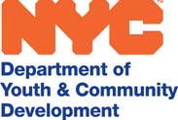

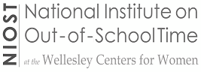

NATIONAL AFTERSCHOOL MATTERS PRACTITIONER FELLOWSHIP
Unique Leadership and Learning Opportunity for Youth Program Leaders

The National Institute on Out-of-School Time (NIOST) at the Wellesley College Centers for Women and the National Writing Project (NWP), with generous funding support from The Robert Bowne Foundation, launched the National Afterschool Matters (ASM) Initiative in 2008.

This initiative includes the Afterschool Matters journal and ASM Practitioner Fellowship Program. Participating cities include Minneapolis, Philadelphia, Pittsburgh, San Francisco and Seattle.

The Department of Youth and Community Development, in partnership with the NYC Writing Project, are pleased to invite you to apply to join the second cohort of the NYC ASM Practitioner Fellowship Program.

Those selected for this competitive Fellowship will:

✓ Learn strategies to engage in program reflection and inquiry to improve programs and practice
✓ Engage in leadership activities to disseminate program improvement strategies
✓ Write a youth-focused inquiry paper; and receive guidance for publication in professional journals

Spring Semi-Public Event
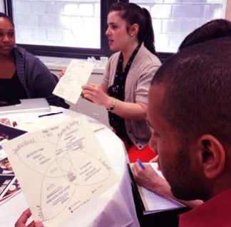

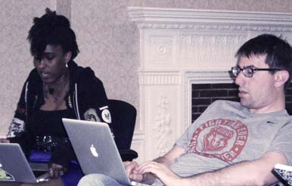

In Their Own Words  2012-2013 NYC Fellows

The Fellowship is a valuable opportunity to do three things that rarely occur on their own during the course of a busy program year including: Connecting with peers who share a common belief in OST and approach their work in different boroughs and with unique methodologies; time to reflect
and research your practice with learning applied to your job in real time; and an opportunity to gain new skills in research, data analysis, and writing that increase the effectiveness of my service to students.

The ASM Fellowship has connected me with many amazing after school workers. It has been great to network with practitioners and engage in dialogue about the field and our work. My action research has helped me identify what
about my work I want to think more deeply about and how I
can affect change from within my own organization.

Before I joined this fellowship, I wondered about my relevance to the field. I also questioned the quality of the work that I was doing. The time spent with much respected colleagues and Fellows has grounded the work that I do. I am more conscientious in what I do and my commitment to
youth overall has increased. Writing
Retreat
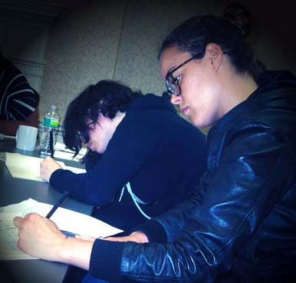

FELLOWSHIP ACTIVITIES AND EXPECTATIONS

The Fellowship requires a one year commitment. Meetings occur twice per month over the course of the academic year and significant time is needed for research, reflection and writing. This involves the same amount of time as a graduate level course.

During the ASMPF program, Fellows receive significant support to foster their professional development, collaboration, writing, and leadership development. Support for Fellows includes:

▪ Fellowship learning meetings;
▪ Individual support to assist with research and writing;
▪ Writing Retreat to provide an opportunity for reflection, collaboration, and writing;
▪ Opportunity to present work at a Research Roundtable at the end of the Fellowship;
▪ Stipend or College Credit: Participants who successfully complete the Fellowship are eligible for a
$500 stipend or three graduate credits in Education.

Program Calendar – see attached schedule
▪ September 2013 to January 2014: Fellows are required to attend twice monthly 3.5 hour Fellowship learning meetings at the NYC DYCD and complete reading, research, and writing projects as assigned.
Meetings will take place from 9:30 AM-12:30 PM on Fridays.
▪ February 2014 to May 2014: Fellows are required to attend monthly meetings at NYC DYCD; writing group meetings; and complete writing projects as assigned.
▪ May 2014: Fellows are required to participate in a spring writing retreat and complete rough drafts of
research articles.
▪ September 2014: Fellows present research findings to funders, colleagues and academia.
▪ October 2014: Fellows participate in a formal Round Table Presentation to the broader community and may be eligible to submit papers for publication.

ELIGIBILITY REQUIREMENTS AND SELECTION PROCESS

ASM Practitioner Fellows are selected through a competitive application process. The NYC selection committee is comprised of staff from NIOST, NYC DYCD, and the NYC Writing Project. Nationally, in collaboration with NIOST, each city selects less than twenty Fellows each year based on a number of factors including:
▪ Experience and Education: Fellows should possess a minimum of three years of experience in education, youth development, and/or the OST field. Fellows must be working part-time or full-time at a OST program in NYC. A bachelor’s degree is required.
▪ Application Materials: Complete, thoughtful, and well written application materials will be considered.
Letters of support and other supplemental materials (e.g., writing samples) will also be carefully reviewed during the selection process.
▪ Fit: The selection committee will consider applicant availability, job responsibilities, and other information, such as areas of expertise, interests, and writing skills, to determine fit.

APPLICATION INSTRUCTIONS

To apply complete the Fellowship application and submit along with your résumé or CV to the following two email addresses: niost@wellesley.edu and CapacityBuilding@dycd.nyc.gov. Please include NYC ASMPF in the email subject line. DEADLINE EXTENDED - Applications must be received by AUGUST 18th.

ADDITIONAL INFORMATION

For more information, visit: http://www.niost.org/Practitioner-Fellowship/practitioner-fellowship-overview or contact: Karen Lachance, (781) 283-2507 or klachance@wellesley.edu. If you have specific questions in regards to the NYC Fellowship contact: CapacityBuilding@dycd.nyc.gov.

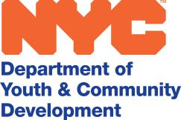

2013
Proposed Meeting Schedule - 2013 - 2014

Friday, 9/13 9:30 AM– 11:30 PM Orientation

Friday, 9/20 9:30 AM – 12:30 PM

Friday, 10/4 or 10/18 9:30 AM – 12:30 PM Meeting or Fall Roundtable for
2012 cohort (to be confirmed)
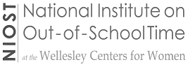

Friday, 10/25 9:30 AM – 12:30 PM Friday, 11/8 9:30 AM - 12:30 PM Friday, 11/22 9:30 AM – 12:30 PM Friday, 12/6 9:30 AM - 12:30 PM Friday, 12/20 9:30 AM - 12:30 PM
2014

Friday, 1/10 9:30 AM - 12:30 PM

Friday, 1/24 9:30 AM - 12:30 PM Friday, 2/28 9:30 AM - 12:30 PM Friday, 3/14 9:30 AM - 12:30 PM Friday, 4/4 9:30 AM - 12:30 PM
Friday, 4/25 9:30 AM - 12:30 PM Semi-Public Event

Friday, 5/9 -10 9:30 AM - 12:30 PM Spring Retreat or
Friday, 5/16 -17 9:30 AM - 12:30 PM Spring Retreat

Friday, 5/30 9:30 AM - 12:30 PM

September/October 2014 final meeting and fall roundtable - dates to be determined

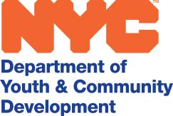

NYC PRACTITIONER FELLOWSHIP | APPLICANT MEMORANDUM OF UNDERSTANDING

By submitting this application, I understand that if I am accepted as a Fellow that I will have the following responsibilities:

• I will attend an orientation to the fellowship on Friday, September 13, 2013, from
9:30-11:30 AM
• I will attend Fellowship meetings on a consistent basis
• I will spend significant time reading/researching and writing in the periods between sessions and I will make the time to reflect on and write about my own practice and program
• I may be asked to meet with other NASM Fellows in between sessions
• I will attend a two-day writing retreat in Spring 2014
• I will produce a final inquiry project and present my work in a public roundtable in the Fall of 2014
• I will contribute to ongoing efforts to expand and sustain the NASM Initiative by sharing updates on my work, positions held, or other activities related to building the OST field
• I have discussed the Fellowship with my supervisor and s/he understands the time required
• As a Fellow, I would represent the NASM Initiative and, as such, would do my best to promote the Initiative where possible, contribute to efforts to share
effective practices in the OST field, and assist with local NASM events and activities when possible

Practitioners who successfully complete the Fellowship, are eligible for either
three graduate English credits OR a $500 stipend.

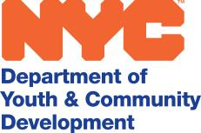

Thank you for your interest in the Afterschool Matters Practitioner Fellowship in NYC. Fellows will be selected through a competitive application process. To participate in the Fellowship this year you must be mid-career level (3 years+) youth services practitioner (e.g. OST, Beacons, Cornerstone, RHY, Service Learning/Teen ACTION, NDA MS/HS). This initiative is generously funded by The Robert Bowne Foundation.

(1) APPLICATION INSTRUCTIONS

To be considered for this Fellowship, applicants must submit a completed application and résumé or CV. DEADLINE EXTENDED - Applications must be received by AUGUST 18th. For questions or more information contact: Karen Lachance at klachanc@wellesley.edu or 781-283-2507. Send completed applications including résumé to the following
two email addresses: niost@wellesley.edu and Capacitybuilding@dycd.nyc.gov. Please include NYC ASMPF in the email subject line.

(2) CONTACT AND OTHER INFORMATION

Last Name: | First Name:
Address: | City: | State: | Zip:
E-mail: | Work Telephone: | Cell number:

What is the highest level of education you have completed?
Bachelor’s degree Major: Master’s degree Field of Study: Doctorate Field of Study:

Because we want to build as diverse a community as possible, we would like to have the following information. Please note these questions are optional:

Date of Birth: / / Gender: Male Female Other

What is your home language?

Are you the first generation to attend college in your family? Yes No

What is your race/ethnicity? (check all that apply) African American/Black
Asian or Pacific Islander
Caucasian or White
Hispanic or Latino

Native American or Alaskan Indian
Other

(3) EXPERIENCE

Please briefly describe any professional development experiences or training you have completed over the past two years.

Current Employer: Current Job Title or Position:

Type of organization:
nonprofit (youth development or education)
nonprofit (other – e.g., arts, STEM)

government private

I work in a
public school setting private school setting community-based setting

faith-based setting public agency setting other (please describe)

I hold a management or administrative position. My job entails (check all that apply) Supervising staff Managing several afterschool program sites other (describe)

If you are a manager, how many staff do you supervise:

I am a practitioner/educator, and work directly with (check all that apply)

high school youth | middle school youth |  | elementary school youth
runaway/homeless youth | disconnected youth |  | other (describe)

I work in another capacity in a school/afterschool program (describe or explain)

How long have you been at your current position? years months

How long have you been working in the field of education/youth work/afterschool work? years months

Are you also employed elsewhere? No Yes
If yes, who is your other employer(s) and what do you do?

(4) INTERESTS AND GOALS

Please respond to the questions below in less than two pages.

1. Why would you like to participate in the National Afterschool Matters Practitioner Fellowship? How does the Fellowship fit into your vision for your own professional growth and development in your work with youth?

2. How do the knowledge, experience and identities of the youth in your program inform your practice? What kinds of experiences and/or knowledge do you think you would bring to the Fellowship?

3. How do you think your participation and reflection will benefit and inform your own site or practice?

4. If applicable, please describe any research/inquiry you have done.

