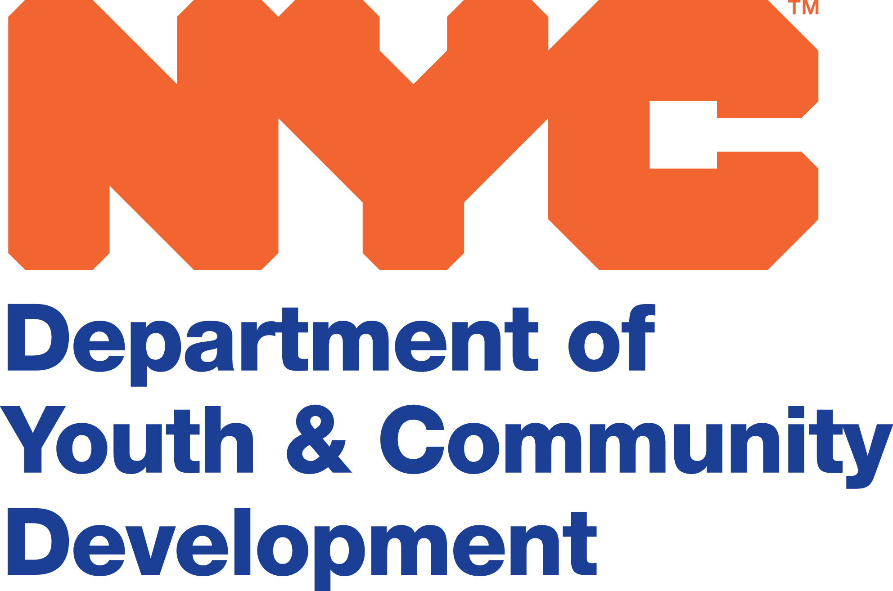
INCLUDEPICTURE "http://nycwritingproject.org/wp-content/uploads/2012/01/NYCWPupdate2.jpg" \* MERGEFORMATINET

INCLUDEPICTURE "https://sites.google.com/site/asmfacilitators/_/rsrc/1335623378291/home/NIOST.png" \* MERGEFORMATINET
INCLUDEPICTURE "https://sites.google.com/site/asmfacilitators/_/rsrc/1335623459744/home/NWP.jpg?height=93&width=200" \* MERGEFORMATINET

National Afterschool Matters Practitioner Fellowship
NYC Application Instructions and form

Thank you for your interest in the Afterschool Matters Practitioner Fellowship in NYC. Fellows will be selected through a competitive application process. To participate in the Fellowship this year you must be mid-career level (3 years+) Out-of-School Time Practitioner who works with middle school or older youth. This initiative is generously funded by the Pinkerton Foundation and the Bowne Foundation.

(1) Application Instructions

To be considered for this Fellowship, applications must include the following:
- Completed Application Form. To access a new application form click on the link at http://www.niost.org/Practitioner-Fellowship/practitioner-fellowship-overview.
- Additional Application Materials. The following materials must be emailed to niost@wellesley.edu
  - Résumé
  - Signed Fellow Memorandum of Understanding, see Section 5 of this application
  - Signed Employer Memorandum of Understanding

(2) Contact and Other Information

Last Name: First Name:
Address: City: State: Zip:

Work Telephone: Cell number: E-mail:

Because we want to build as diverse a community as possible, we would like to have the following information. Please note these questions are optional:

Date of Birth: / /

Gender: Male Female Other

What is your primary language?

What other language(s) do you speak?

What is your race/ethnicity? (check all that apply)

African American/Black
Asian or Pacific Islander
Caucasian or White
Hispanic or Latino
Native American or Alaskan Indian
Other

What is the highest level of education you have completed?

Bachelor’s degree Major:
Master’s degree Field of Study:
Doctorate Field of Study:

Are you the first generation to attend college in your family?

Yes

Please briefly describe any professional development experiences or training you have completed over the past two years.

(3) Experience

Current Employer: Current Job Title or Position:

Type of organization:
nonprofit (youth development or education)
nonprofit (other – e.g., arts, STEM)
government
private

I work in a
public school setting
private school setting
community-based setting
faith-based setting
public agency setting
other (please describe)

I hold a management or administrative position. My job entails (check all that apply)

Supervising staff Managing several afterschool program sites other (describe)

I am a practitioner/educator, and work directly with (check all that apply)

high school aged youth middle school aged youth other (describe)

I work in another capacity in a school/afterschool program (describe or explain)

How long have you been at your current position? years months

How long have you been working in the field of education/youth work/afterschool work? years months
Are you also employed elsewhere? No Yes
If yes, who is your other employer(s) and what do you do?

NOTE: This Fellowship is middle school and/or older youth specific. All of the final projects produced will have a middle school and/or older youth focus.

(4) interests and goals
Please respond to the questions below in less than two pages.

- How would you describe the youth that you currently serve?
- In what ways do these youth’s knowledge, experience and identities inform your practice?
- Why you would like to participate in the National Afterschool Matters Practitioner Fellowship that focuses on middle school and/or older youth?
- Describe where you see yourself in five years. What is your vision for your own professional growth and development in your work with youth?
- What kinds of experiences and/or knowledge do you think you would bring to the Fellowship?
- How do you think your participation and reflection will benefit and inform your own site or practice?
- If applicable, please describe any research/inquiry you have done regarding your work with or on behalf of children and youth.

(5) Applicant Memorandum of Understanding

I understand that if I am accepted as a Fellow that I will have the following responsibilities:

- I will attend an orientation to the fellowship on October 3rd^{th} from 10-11:30 a.m.
- I attend Fellowship meetings on a consistent basis;
- I will spend significant time reading/researching and writing in the periods between sessions;
- I may be asked to meet with other NASM Fellows in between sessions;
- I will make the time to reflect on and write about my own practice and program;
- I will attend a two-day writing retreat in Spring 2015;
- I will produce a final inquiry project and present my work in a public roundtable in the Fall of 2015;
- I will contribute to ongoing efforts to expand and sustain the NASM Initiative by sharing updates on my work, positions held, or other activities related to building the OST field; and
- As a Fellow, I would represent the NASM Initiative and, as such, would do my best to promote the Initiative where possible, contribute to efforts to share effective practices in the OST field, and assist with local NASM events and activities when possible.

I give the National Institute on Out-of-School Time (NIOST), Wellesley Centers for Women, National Writing Project, the New York City Writing Project and the New York City Department of Youth and Community Development permission to use my image, likeness, name and other identifying information in print and electronic collateral, including audio and video presentations developed for use at their discretion unless specified below. I will notify NIOST of any papers, presentations or interviews of my work offered, created or printed as a result of or during the Fellowships, and will acknowledge the sponsors on all project-related publications as “The Robert Bowne Foundation, The Pinkerton Foundation and National Institute on Out-of-School Time,” i.e., This project was supported in part by The Robert Bowne Foundation, The Pinkerton Foundation and the National Institute on Out-of-School Time.

_____________________________________ _____________________________________
Signed Date

Practitioners who successfully complete the Fellowship, are eligible for a $500 stipend

Please submit this application, along with the attached AGENCY Memorandum of Understanding (MOU) which is to be signed by your immediate supervisor. You should include your résumé or CV as well as a letter of support from your agency with this application. Applications must be received by August 8th.

National Institute on Out-of-School Time
National Afterschool Matters Practitioner Fellowship Program
Wellesley Centers for Women
Wellesley College, 106 Central Street
Wellesley, MA 02481
niost@wellesley.edu
fax: 781-283-3657

For questions or more information on the Practitioner Fellowship in general, contact: Elizabeth Meister at emeister@wellesley.edu or 781-283-2607.

Proposed 2014-15 NYC Fellowship Dates

October 3, 2014 Orientation
October 24, 2014 First Meeting
November 7, 2014
November 21. 2014
December 5, 2014
December 19, 2014
January 9, 2015
January 23, 2015
February 6, 2015
March 13, 2015
April 17 or 24, 2015 Semi-Public Event
May 8/9 or 15/16 Writing Retreat
May 29, 2015
June 12, 2015

